**Lab Manual # 05**

**Advance use addressing modes in different language programs using EMU8086.**

**Base-Plus-index Addressing:**

Base-plus-index addressing is similar to indirect addressing because it indirectly addresses memory data. In the 8086 through the 80286, this type of addressing uses one base register (BP or BX), and one index register (DI or SI) to indirectly address memory.

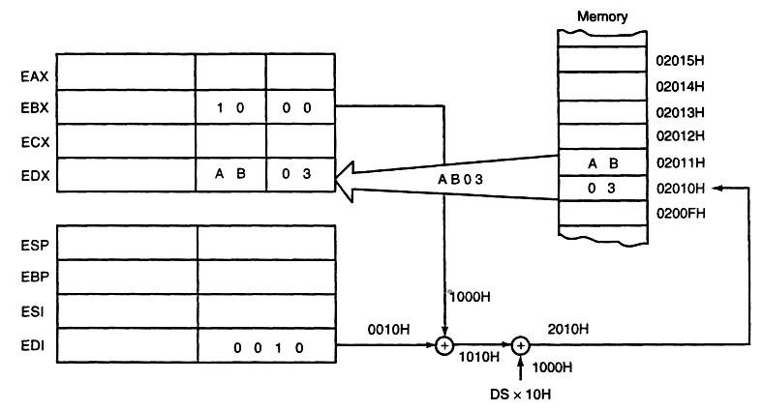

An example showing how the base-plus-index addressing mode functions for the

MOV DX, [BX+DI] instruction. Notice that memory address 02010H is accessed because

DS = 0100H,

BX = 1000H, and

DI = 0010H.

**Example**

DB 29H ; sample data at element 10H

DB 30 DUP (?)

MOV BX, OFFSET ARRAY ; address ARRAY lea bx, [array1]

MOV DI, 10H ; address element 10H

MOV AL, [BX+DI] ; get element 10H

MOV DI, 20H ; address element 20H

MOV [BX+DI], AL ; save in element 20H

Array1…

ARRAY DB 16 DUP (?) ; setup ARRAY

ret ; exit to DOS

**CMP:**

This instruction compares two operands, discarding the results and setting the flags

**Syntax:** cmp, op1, op2

op1: register or memory

op2: register, memory, or immediate

Flags Affected: OF, SF, ZF, AF, PF, CF

**Lab Tasks**

**Execute the following tasks CLO [1]**

**Task1: Run the following code and observe the registers/ memory locations:**

org 0x100 mov ax,10 mov bx,10

mov [200h], ax mov [201h], bx ret

**TASK 2:** Write a code to add first ten natural numbers starting from the memory location 0200H?

**TASK 3:** Write a code to transfer a block of data from source memory block to destination memory block. Use any starting address.

**TASK 4:** Write a code to perform addition on 8-bit data stored in consecutive memory locations (10) and store result in next memory locations. Use any starting address.

**TASK 5:** Write a code to sort the given array in ascending order?

10,5,13,1,15,16,5,2